**Chapter 1 Download Oracle SQL Developer and 11g**

If you are using the PC in SOC, you do not need to download Oracle SQL Developer and 11g and you can skip this part. If you are trying to practice SQL in your own PC, you can follow the steps below.

**Download Oracle SQL Developer**

Go to the download website

<http://www.oracle.com/technetwork/developer-tools/sql-developer/downloads/index.html>

Choose “Accept License Agreement”.

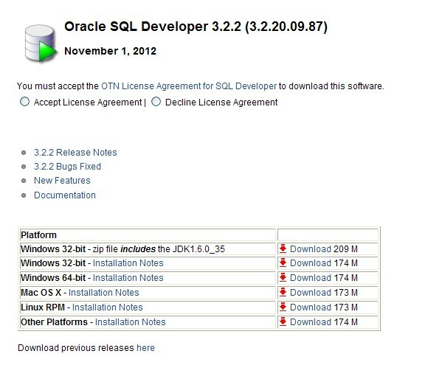

Note that it is required to install JDK first, in order to run Oracle SQL Developer. The version of the JDK is also required. Please choose “Installation Notes” to check the required version of JDK of your PC. If the correct version of JDK is not installed, install it first.

Download the corresponding version of Oracle SQL Developer according to the OS of your PC.

If you are not signed in as a user of Oracle, it will ask you to sign in, as 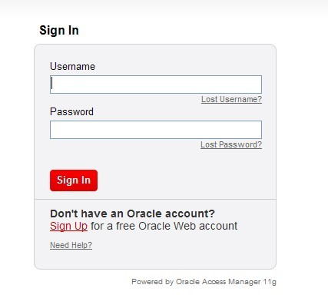

If you are not a registered user, you have to sign up first, by click on “Sign Up”. Finish the sign-up process and you become a user of Oracle. Then you sign in and the downloading should be automatically started.

Unzip the downloaded zip file into a folder. You can find “sqldeveloper.exe” in the folder and double click it. For the first time you try to run it, it will ask for the java path. You have to browse the path of “java.exe” in your PC. Typically you may find it in

C:\Program Files\Java\jdk1.6.XXX\jre\bin

Now you can use Oracle SQL Developer. We will show you how to use it in Chapter 2.

**Download and install Oracle 11g**

Go to the download website

<http://www.oracle.com/technetwork/database/enterprise-edition/downloads/index.html>

Choose “Accept License Agreement”.

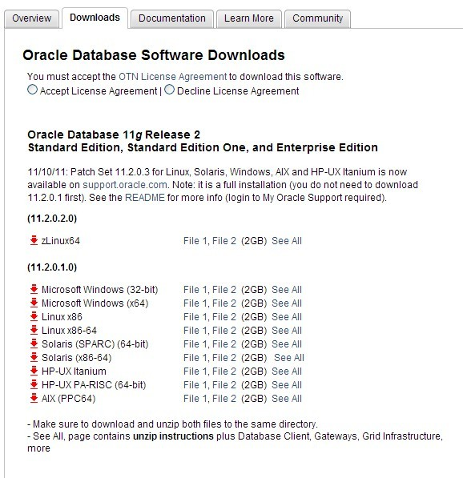

Download the corresponding version of Oracle SQL Developer according to the OS of your PC.

It may also ask you to sign in, and you can follow the same process before if you did not sign up.

Unzip the two downloaded files into a same folder, e.g. D:\Oracle-setup. The contents unzipped from the two files constitute an entire setup folder (D:\Oracle-setup\database).

Launch the setup program “setup.exe” located inside the above setup folder. To install Oracle 11g, please follow the steps below.

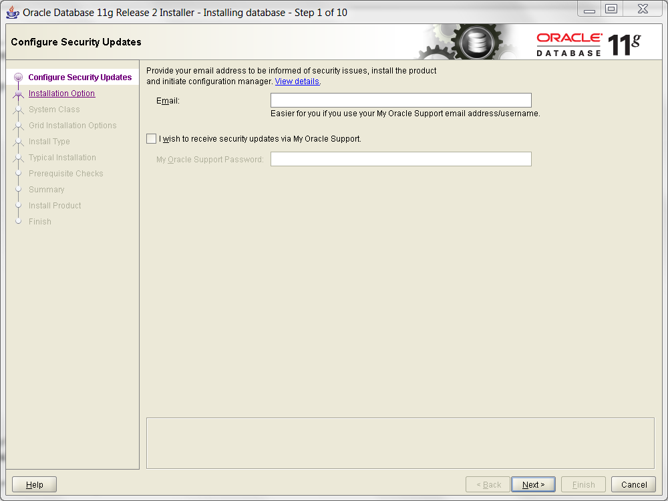

You can skip to input any email if you do not want to.

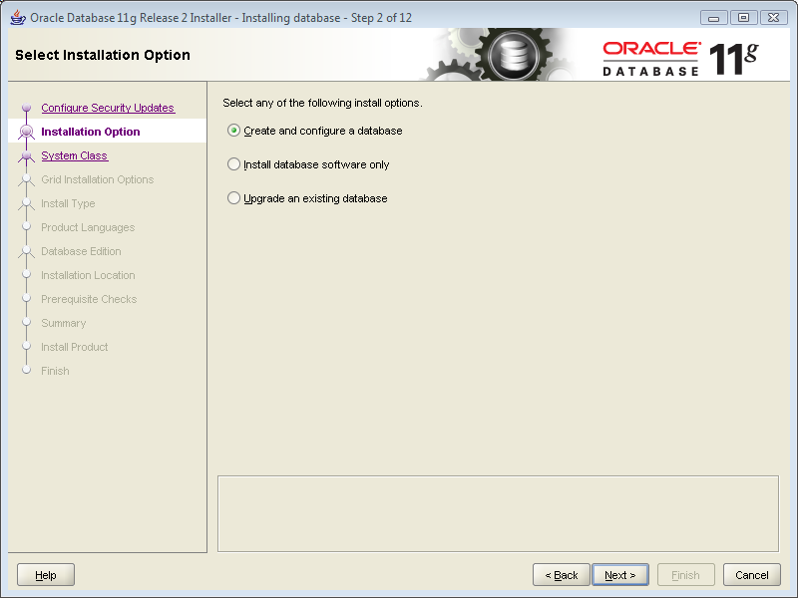

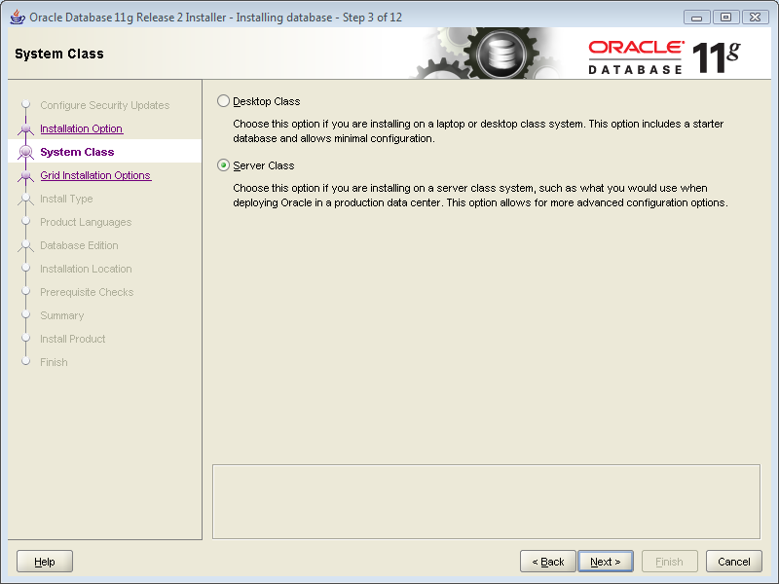

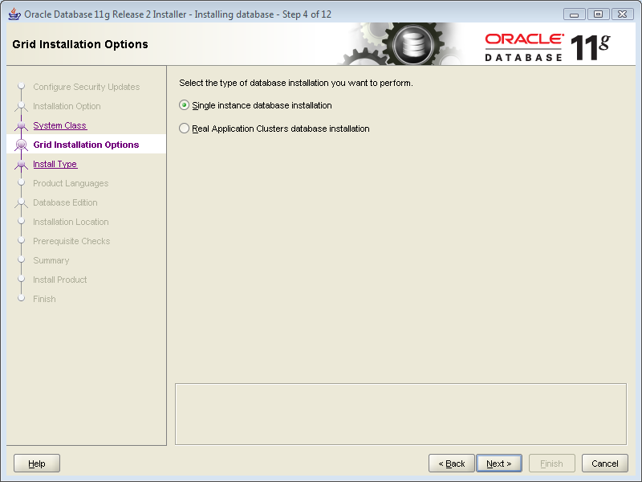

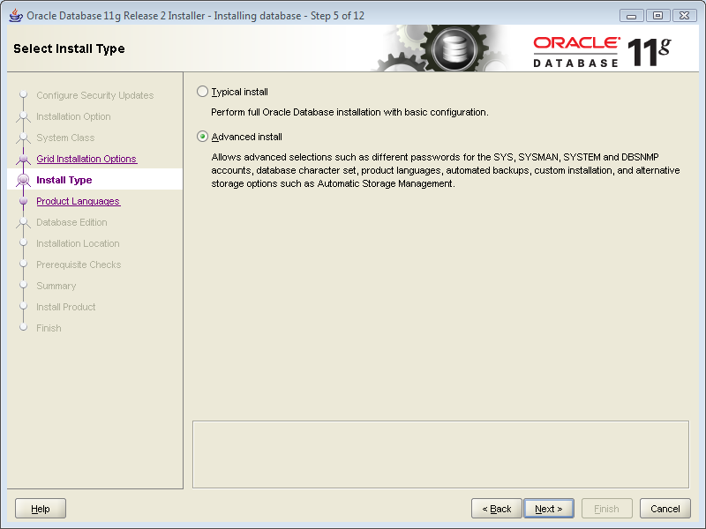

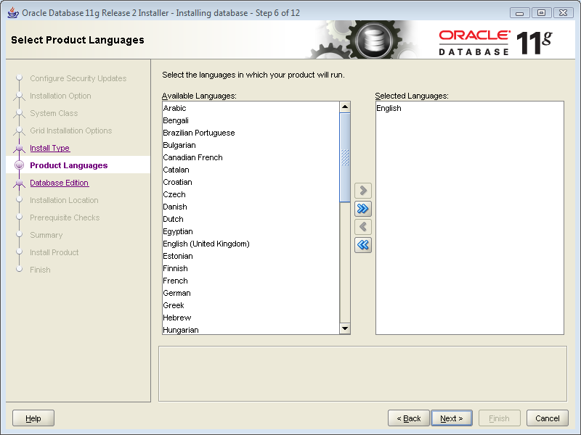

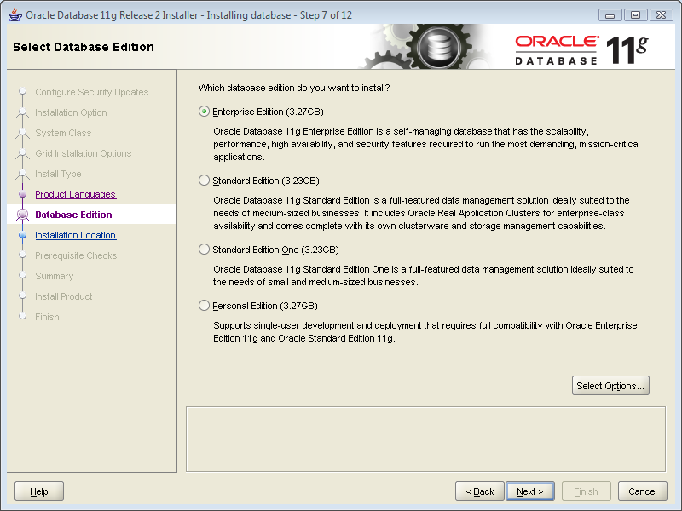

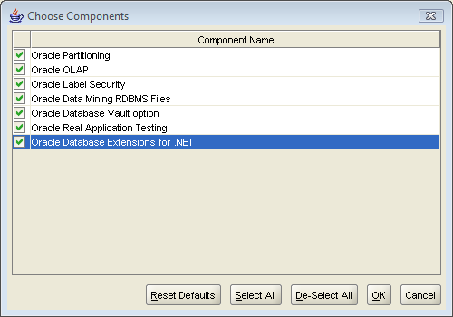

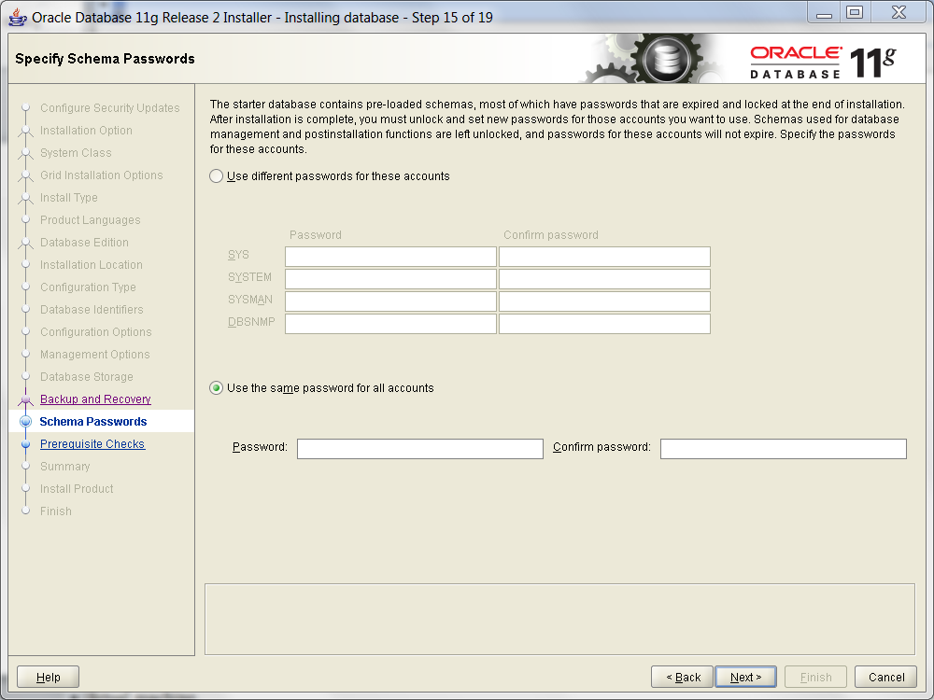

Set the password for these admin accounts. Do remember the accounts and passwords.

We will show you how to create a database in your own PC and connect to it using Oracle 11g and Oracle SQL Developer in Chapter 4.

**Chapter 2 Use Oracle SQL Developer inside SOC, and try to connect to the server in SOC**

Double click on “sqldeveloper.exe” and you may need to wait for a few seconds for the application to start.



You will see the following window



Right click on “connection”, and choose “new connection”. You will see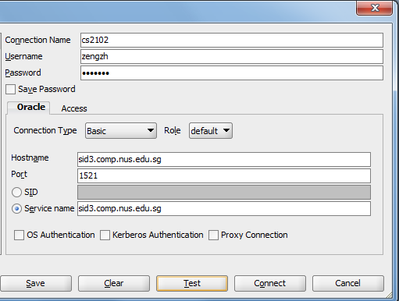

For the “connection name”, you can give any name you want.

For the “username” and “password”, fulfill the information that the Database administrator has sent to you by email.

For the “hostname” and “service name”, fulfill “sid3.comp.nus.edu.sg”.

After entering the information, choose “test”. If it poses the information “state: success”, then click on “connect”.

**Chapter 3 Use Oracle SQL Developer outside SOC, and try to connect to the server in SOC**

If you are out of SoC, you need to use SoC-VPN to access the server in SoC.

**Download the SoC-VPN**

Go the website:

<https://docs.comp.nus.edu.sg/node/2454>

Step1.

Download the OpenVPN Windows Installer from <http://download.comp.nus.edu.sg/download/openvpn-2.1.1-install.exe>  and save it onto your desktop.

Step2.

For Windows 7 only: Right-click on the saved OpenVPN Windows Installer file (e.g. openvpn-2.1.1-install), select Properties, click on Commpatibility tab, then:

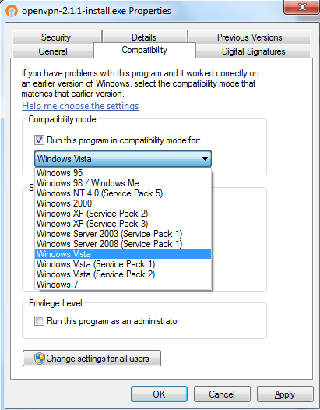

1. Check “Run this program in compatibility mode for”, then select Windows Vista.
2. Click OK.

Step3.

Run the OpenVPN Windows Installer and follow through to complete the installation of OpenVPN. When OpenVPN installation is completed, an OpenVPN folder and an OpenVPN GUI connection shortcut will appear in your Start Menu Programs folder and in your desktop.

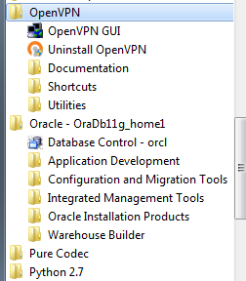

Step4.

Configure OpenVPN with SoC-VPN connection profiles:

1. Download the SoC-VPN configuration file: <http://download.comp.nus.edu.sg/download/socvpn.ovpn>
2. Download the certificate file: <http://download.comp.nus.edu.sg/download/ca.txt>
3. Save the downloaded files socvpn.ovpn and ca.txt into the OpenVPN configuration folder *\your installation path\OpenVPN\config\.*

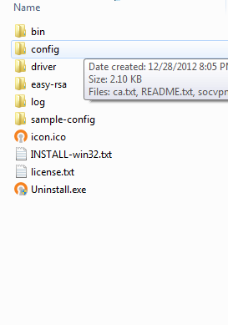

**Connect to SoC-VPN:**

Step1. Start the OpenVPN GUI:

1. For Windows Vista and Windows 7: Right click the OpenVPN GUI shortcut in your desktop and select "Run as Administrator" to run the program or go to Start → All Programs → OpenVPN GUI, right click and select "Run as Administrator" to run the program.
2. For Windows XP: Double-click the OpenVPN GUI shortcut or go to start → All Programs → OpenVPN → click OpenVPN GUI to run the program.

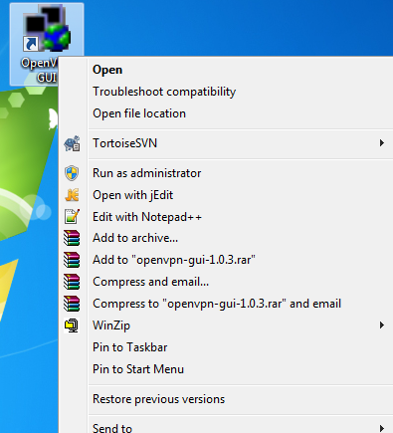

Step2. Right-click on the OpenVPN icon in Notification area (systray), click Connect.

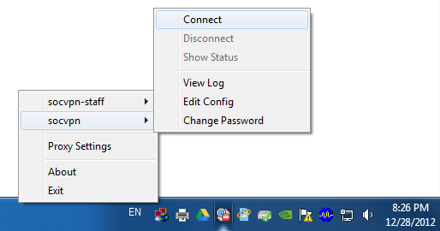

Step3. Type in your NUSNET userid (e.g. nusstu\u0123456 or nusstf\comuser) and password in the authentication window.

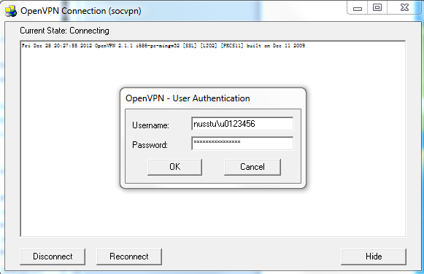

Step4.When the VPN connection has been established, your browser will launch and load a webpage with the message "Welcome to SoC-VPN". You are now securely connected to SoC-VPN.

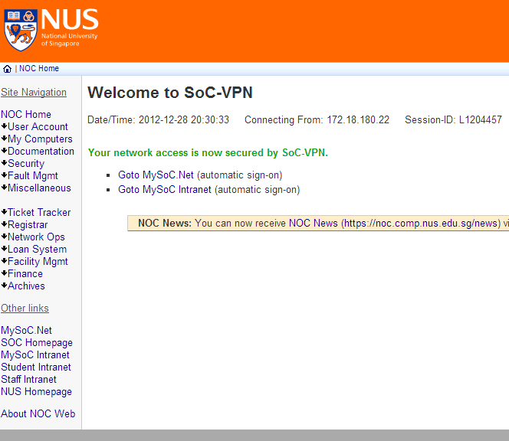

**Connect to the server.**

Now you can connect to the server in SoC as you are in SoC





**Chapter 4 Use Oracle 11g to create database in your own computer**

After installing Oracle 11g, Oracle SQL Developer is also included.

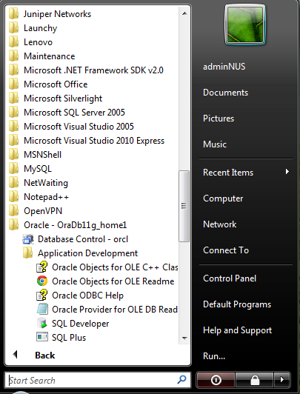

Run SQL Developer. Log in as a system administrator. 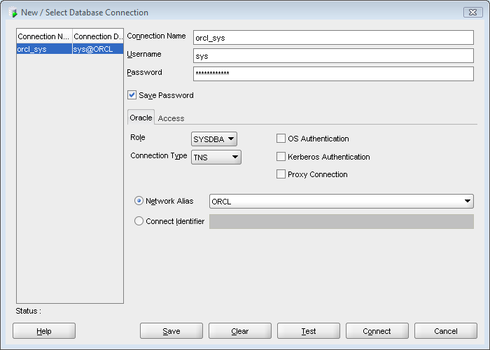

Do note that the “username” is “sys”; the password is the one you set during the installation; choose the “Role” as SYSDBA.

Click “Test” first, and then click “connect”, as you did in the lab.

After logging in as an administrator, you can create a normal user.

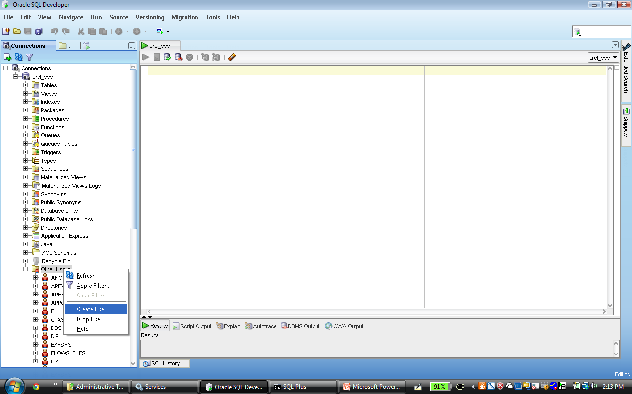

Chose the tab “User”, and fulfill the user name and password. Choose “Default Tablespace” as “USERS” and choose the “Temporary Tablespace” as “TEMP”.

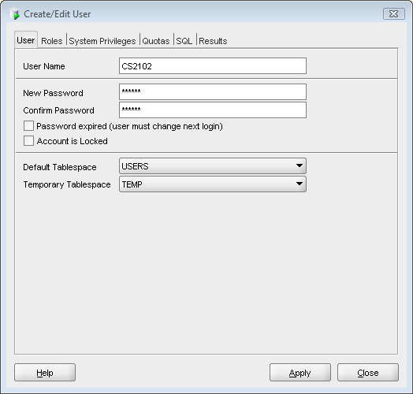

Choose the tab “Roles”. Click “Granted” and “Default” for “CONNECT” and “RESOURCE”.

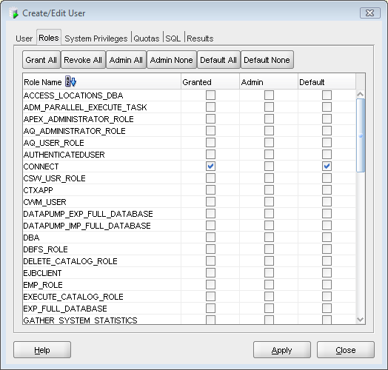

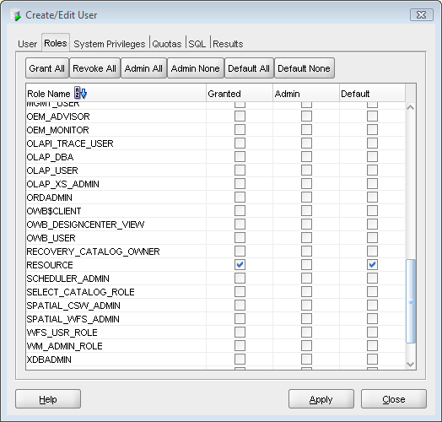

Choose the tab “System Privileges”, click “Granted” for “UNLIMITED TABLESPACE”.

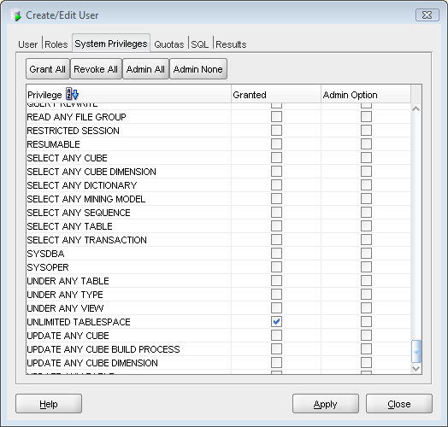

Then you can log in as the new user you created. Do note that select “Role” as “default” and the value of SID should be “orcl”.

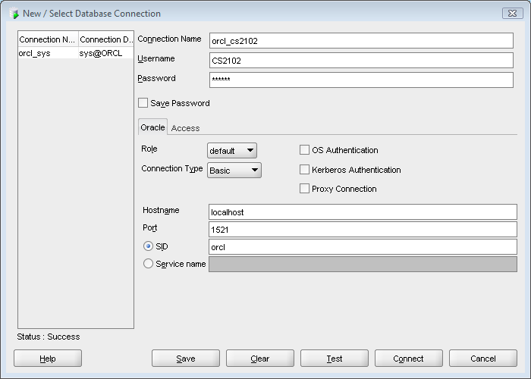

**Chapter 5 Sample Problems and solutions of using SOC VPN provided by the students**

**Sample 1.**

Problem:

The operating system is WINDOWS 8.

And the error message shows that

"openvpn Options error: --route-up ***"

Solution:

Deleted the last line of the setting file which is :  
  
route-up "start <https://noc.comp.nus.edu.sg/netlogon>"

Source provider: Wu Long (a student taking CS2102 in Sem II, AY2012-2013)

**Chapter 6 Sample Problems and solutions of installing and starting-up Oracle 11g provided by the students**